Project Name |  | Confidentiality Level
DBMS Project |  | For Recipients’ Reference Only
Project ID | Version | Document Code
BP | 1.0 | BP

DBMS Project Start Report

15301002 程辰
15301009 倪施杰



Copyright © Ruankosoft Technologies (Shenzhen) Co., Ltd.
All Rights Reserved
Revision Record
Date | Revision Version | CR ID /Defect ID | Sec No. | Change Description | Author

Content
1. Project Proposal 5
2. Team building and Schedule 7
3. Risks Evaluating and Mitigating 7

Keywords: Words that will reflect main contents of the document.
Abstract :
List of abbreviations : Describe abbreviations in this document, full spelling of the abbreviation and Chinese explanation should be provided.
Abbreviations | Full spelling | Chinese explanation
SDI | Single Document Interface | 单文档界面
MFC | Microsoft Foundation Classes | 微软基础类库
DBMS | Database Management System | 数据库管理系统
RDBMS | Relational Database Management System | 关系型数据库管理系统
C/S | Client/Server | 客户/服务器模式
MVC | Model View Controller | 模型—视图—控制器

Project Proposal
1. Project ID:

2. Project Introduction: 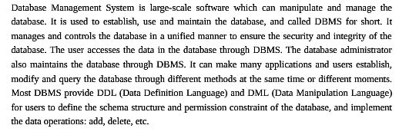
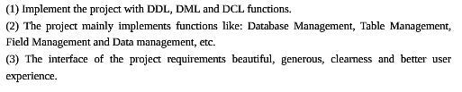
3. Project objective:

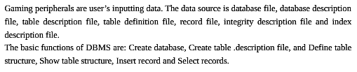
4. System boundary:

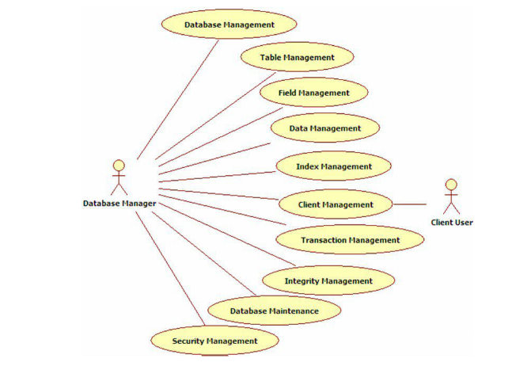
5. Workload assessment:
Module | Sub-module | Workload（person/day） | Description
Create project |  | 1 | Create a MFC SDI application.
Interface Design |  | 1 | Design main interface of DBMS.
Data Structure |  | 1 | Design data structure to implement core functions of DBMS.
Exception  Handling |  | 1 | Design the exception handling method in the program.
Create Database |  | 3 | Create a default database, named “Ruanko”.
Create Table Description File |  | 3 | Generate table description information.
Define Table Structure |  | 3 | Input the field information of the table, save into the table definition file (.tdf), and display in the tree view and the list view.
Show Table Structure |  | 3 | This function includes read*.tdf file and display table structure.
Insert record |  | 3 | Insert a row of record in a specified table, and save to the record file (*trd).
Select records |  | 1 | Read the *.trd file of the specified table, and select all record, then display in the list view.
Workload in total（person/day） | 20 person/day
Remarks: Person/day means workload of the number of person & day

Team building and Schedule
1. Project Plan： 2017.4.26——2017.5.21

2. Chief Project Manager： Number：15301002 Name：程辰

3. Project Manager： Number：15301009 Name：倪施杰

Risks Evaluating and Mitigating
1. Technical Risks：
(1) Unfamiliar for Visual studio 2012 and 2015, use less of MFC Dialog, MFC SDI.
(2) Not familiar with DDL/DML/DCL function of the DBMS.
Resolution:
For self-learning and timely communication, mainly learn about the database knowledge.

2. Management Risks：
(1) Plan is not fully, so it is different to keep with the project schedule.
(2) The content of the project is too much.
Resolution：
(1) For project development, we should fully prepared and effective for time management.
(2) Seize the time to prepare the individual software quality.
3. Other Risks：
(1) Because of power outages and other reasons, resulting in the loss of project data.
(2) Network status is poor, resulting in broken network.
Resolution：
(1) Back up the data frequently.
(2) Reasonable to arrange time to set aside space to solve risk.

